Proceeding

An Exercise Circuit to Reduce a Sedentary Lifestyle in the Workplace Environment

Christopher Sánchez 1, Gustavo López 2, Gabriela Marín 3

1 Universidad de Costa Rica; [christopher.sanchezcoto@ucr.ac.cr](mailto:christopher.sanchezcoto@ucr.ac.cr)

2 Universidad de Costa Rica; [gustavo.lopez_h@ucr.ac.cr](mailto:gustavo.lopez_h@ucr.ac.cr)

2 Universidad de Costa Rica; [gabriela.marin@ucr.ac.cr](mailto:gabriela.marin@ucr.ac.cr)

† Presented at the title, place, and date.

Received: date; Accepted: date; Published: date

**Abstract:** Even with the amount of information and the available evidence of the adverse effects of not exercising enough, we continue having sedentary habits that, in most cases, are the tip of the iceberg for a broad number of diseases. In this paper we are going to propose a circuit of exercises to apply in the place where people spend most of the day, the workplace. We incorporate a series of exercises that involve most of the body, from the legs to the arms, with different types of movements. The objective is help reduce the stress, put our bodies in a state of activity, and create healthy habits.

**Keywords:** exercise, circuit, workplace, sedentary lifestyle, healthy habits

1. Introduction

Being sedentary is defined as spending excessive time sitting or in a reclined posture while participating in activities with an energy expenditure of less or equal to 1.5 metabolic equivalents during wake time [1]. Nowadays, sedentary habits are generally deemed as unhealthy. Moreover, having an active lifestyle has proven to be one of the most effective ways to reduce the possibility of chronic diseases.

On the other hand, the workplace is, in many occasions, the place where people spend most of their daily time. That is why it is important to develop a common culture to have an active lifestyle even in our daily activities in the office. Eight or nine hours is the average work time by day for an adult, and according to recent studies [1] just a few people achieve some time of physical activity during working hours, and most spend excessive time sitting.

Obesity is becoming one of the major disabilities in the world and as mentioned before, the time people spend at the office might be a good starting point in order to decrease the sedentary lifestyle. Despite the large number of studies and recommendations, people are still having bad habits in their homes and workplaces regarding the physical activity they perform each day. Most people do not meet the weekly requirements of minimal physical activity. 150 minutes of exercise is the recommended time of physical activity per week [2, 3] for a person, and even the people that accomplish this goal weekly are not exempt of having issues due to sedentary behaviors.

Workplace is an ideal place to implement exercises as it involves all kinds of people, some with sedentary behavior, and some that exercise regularly, and can motivate others. We are going to propose an exercising technology supported platform to be used in the workplace environment, in order to reduce the sitting time and be able to introduce physical activity that otherwise would not be even considered by some of the people. The chosen exercises cover most of the main areas of the body we need to move/exercise in order to reduce the sitting time. They involve stretching key points that will result in a better posture and will make our body to be in an active state.

2. Related Work

Nowadays, even our watches remind us to stand up and move after several time of inactivity. We tried to propose simple exercises that do not take a long time to be executed. They are focused in braking the sitting time and making the people perform small amounts of physical activity, without having to leave the office.

As indicated in [4], there are still some people which do not take sedentary lifestyle as a serious problem in our society. Our purpose is to raise awareness and create a series of exercises that all of us can install in our workplaces. The goal is that exercise should not take a lot of time and should not interfere in work activities, while making us active for several short periods of time during the day.

According to studies [8, 9], sitting for long periods of time without even standing up has a negative impact in blood glucose. This can be avoided with a bit of physical activity, or how they indicate it, with light-intensity physical activity (LPA). There is no need to have a complete exercise routine for every day, but one has to have in mind that even little time standing up can reduce the possibility of having deceases.

Studies like [5] reveal that workplace is an important environment for physical activities promotion and initiatives, and a key place for addressing these issues. It is worrying that people spend more than half of their daily life in sedentary activities as indicated in [7], and some of the workplace environments do not encourage people to have physical activity during the day.

Several authors describe the importance of having healthy living habits. They insist in incorporating physical activity in a minimum of 150 minutes a week, creating a culture and understanding the bad results and dangers of having a sedentary lifestyle. Most of the studies focus in gathering data of how much time people is inactive vs. how much exercise people do in their daily basis. Articles proposing a single exercise guide is the most look alike type of related work.

Gardner et al [4] trying to provide guidance, noticed that most people were not sure about their knowledge or where the information was taken from. Confusion and misapprehension are some of the words used to describe the knowledge of people regarding this problematic. However, there is evidence of a recent consensus statement that provide some guidelines regarding the sedentary behavior, especially for desk-based employees in the United Kingdom [6].

Our approach includes a series of individual exercises to be implemented in workplace environments, and a way, not to measure exercise time, but to know if people are performing the exercises correctly. With nowadays technology, we have all the means to remind us the exact time we need to move, or to stand up after a long period we have been sitting. We want to define a circuit that help people perform correctly some exercises.

3. Exercise Circuit Platform

Our circuit consists of a set of four exercises that need to be performed one by one. For each one, we will have a sensor or a set of sensors, depending on the exercise, to detect the movements required for its successful completion. In Figure 1 we have the conceptual model of the exercises set. They can be performed in any order, or as the user wants to.

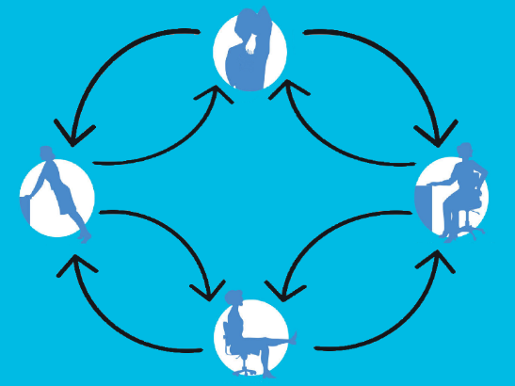

**Figure 1.** Exercise circuit conceptual model

The exercises in the exercise circuit are the following:

1. Shoulder Stretch
2. Leg Extension
3. Spinal Stretch
4. Knee Flex Push Up

The set of exercises we chose can be performed by most of the people and should never make the user feel any kind of pain and/or discomfort. However, at anytime that the user experiences some severe pain or out of the ordinary, the exercises should be stopped at that moment.

The idea for creating the exercise circuit is to incorporate sensors on items we have at the office like chairs and desks; that is, to integrate the sensors without being intrusive in the working environment. Therefore everybody can continue their daily activities and make some exercise at their desks (by just going to the corresponding exercising station in the software application) when needed. In this way no special exercising devices have to be installed at the office. Everything you need for exercising is there, and the exercises are very simple for everybody to perform without any excuses.

Several touch sensors are used for the exercises. The exercises can be identified by a touch sensor positioned close to the user. Some of them are located in the desk, other in the chair in different positions. This way the user must be in the correct position for exercising, and executing the exercise tasks in a correct way.

The interface that we use consists of an application that indicates the exercise that must be performed. The application shows an image with the exercise to be performed in every station and provides a log with the information and set of events each sensor is receiving. It also provides the user with exercise messages. We will take a deeper look at the application next.

4. Interface Implementation

Our implementation is based on Phidgets Touch/Human input sensors. The application was created using simple HTML and the Phidgets libraries controlled through JavaScript. The very first screen of the interface is just a list for selecting the exercise to perform in that particular working station. This allows executing all the exercises in any of the stations. The only requirement is to have the required sensor or sensors needed by each exercise. Figure 2 shows the basic interface for exercise A in particular. The interface is the same for all the exercises we are proposing here. The image identifying each exercise is located in the left side of the application. On the right hand, log field is located. It will contain all the information of the events received from the exercise sensors. On Fig. 2 we can see how the log field works, showing that the sensor for exercise A was touched several times in a row. This log ends with a message indicating the exercise was finished.

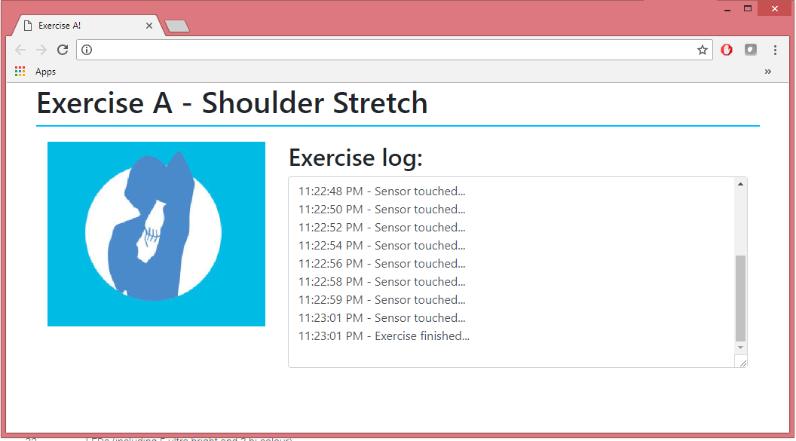

**Figure 2.** Exercise circuit conceptual model

In this case, the interface is working for Exercise A that requires only a single sensor. If the exercise requires more than one sensor, the application will show which sensor was pushed at any given time. If the user touches the wrong sensor, the log will show an error message and a pop-up window will indicate the user about the wrong event received from the sensor.

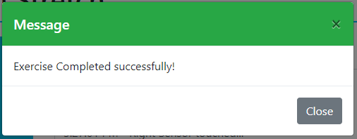

**Figure 3.** Successful message

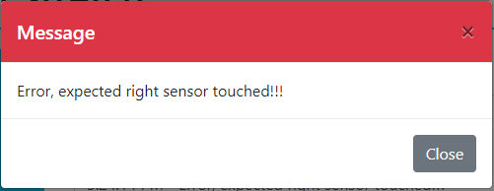

**Figure 4.** Error message

Figure 3 and 4 show the messages presented to the user depending if the exercise was correctly completed or an error occurred, respectively. Phidgets provide libraries for different technologies like Java, C, and C#. JavaScript was selected in order to be able to create a web application that can be seen from a more broad number of devices like computers, cell phones, tablets and any device with a web browser.

The sensors chosen for the physical implementation are the Interface Kit and the Touch Sensor shown in Figure 4. In particular, the user will only interact with the touch sensor. The interface is only needed for providing the necessary logic for the sensor to be able to recognize inputs and send them as messages to the libraries we are using. The Phidgets provide a wide number of sensors that can be used in various applications, as touch sensors, slide sensors, rotation sensors, gyroscope sensors, among others. But for our purpose only touch sensors were used.

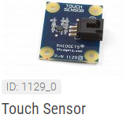

**Figure 4.** Phidget Touch Sensor

The only requirement for the application to run is to have the Phidgets Control Panel running on the computer. There are two options, the first one is to use the current computer as the main device for the Phidgets, and the second one, and the one we chose, was to create a Network server to work with JavaScript. The Network servers need a host and a client. The host is the computer where the Phidgets will be physically connected. The client is the computer from where we are going to open the application. For the purpose of this paper, the host and the client are the same, so the sensor will be connected to the same computer from where it is going to be tested.

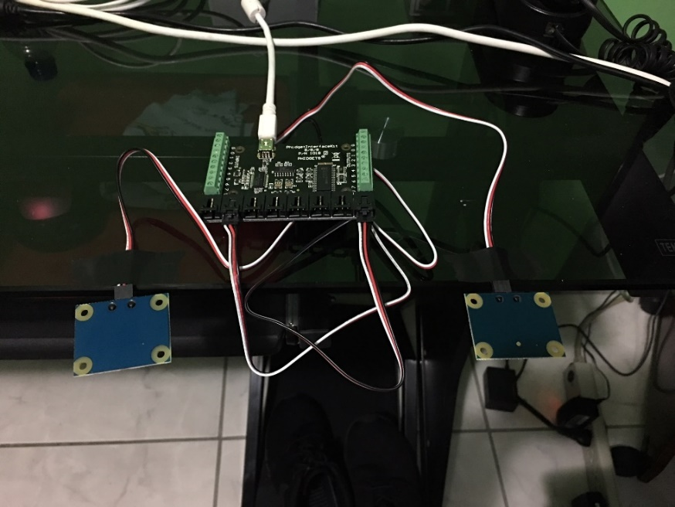

**Figure 5.** Sensors connected to interface kit

Figure 5 shows how the sensors connect to the interface kit. The interface kit provides 8 channels to connect the required sensors. Connecting more than one sensor requires a bit of configuration in the code in order to identify one sensor from another. For Exercises B, C and D, this configuration was required as each needs two sensors. The way the application is implemented allows performing all the exercises in a single workstation without the need to modify or make connections between the sensors, just select the desired exercise from the initial screen.

5. Exercise Implementation

5.1 Exercise A- Shoulder stretch exercise

This exercise is focused for the upper part of the body. The shoulders and the arms are where more stress can be cumulated; resulting in disconformity and illness as well as some posture issues that can be very painful and difficult to correct if it is not taken in consideration when needed.

Once in the exercise workstation, the user has to raise his arm and put it behind his back and touch the sensor located in the back of the chair with each arm. This exercise is performed, one arm at a time. With this set of movements the user will be stretching his shoulders and his arms. The idea is to stretch the muscles as much as possible, and be able to reach the sensor that is located in a specific position. A single touch of the sensor is required to complete successfully the exercise for one arm.

The physical implementation is a touch sensor in the back of the desk chair which senses the user input. This event gets captured by the software and then shows a message in the screen. The user needs to perform this several times to complete the exercise station and move to the next one, 5 times per arm. Only one sensor is used in this exercise because both arms need to reach the exact same position, one by one.

The idea of using the chair as the main device in an exercise station is to use everything we have in the workplace environment, and in a natural position that will create no confusion at the time of the exercise execution. The chair is an item than can have a much more broad approach to people´s wellness, or illness. Some studios already indicate, using an incorrect posture can be the reason for many of the back pains.

It is important to adopt a correct sitting posture at the time of performing the exercise. If the posture is not the correct, the user might be facing issues reaching the desired point where the sensor will be located. If the user has shorter or longer arms, the corresponding sensor can be relocated.

The chair is sometimes the place where we spend most of the time in our daily activities, so it is a good idea to implement this exercise in the chair.



**Figure 6.** Shoulder stretch exercise

Figure 6 shows the basic idea for the arm movements, where the user needs to reach his arm to a certain position in his back in order to complete successfully the exercise. In this case that is the position where the sensor is placed in the back of the chair.

5.2 Exercise B- Leg extension exercise

This exercise is focused on the legs. Being in a sitting position for a long period of time affects the legs in ways one might not image. People need to have activity for the blood to reach every part of the body, and sitting brings pressure to the legs making it difficult for the blood to transit there. Executing a single exercise can activate the blood flow in our legs and giving us a stronger and healthier body. Excessive sitting with no physical activity is a real problem and can bring much more issues than people are aware of.

As exemplified in Fig. 7 sitting in the chair, the user has to raise his legs one by one until reaching a sensor located below his desk. The legs should start in the normal and correct sitting position. The user must raise one leg to a horizontal position, then the other one. When each leg gets to the horizontal position, user should able to reach with his feet the sensor located for this task. In this exercise we introduce the desk as an exercise item as it is a key asset for every workplace. This exercise needs several touches of the sensors to be completed successfully. Same as the previous exercise, it is very important to be sitting in the correct position to raise the legs without putting pressure to the back.



**Figure 7.** Leg extension exercise

The sensor must not be pressed more than one second each time. Just a single touch and the user should be ready for the other leg. Another variant of this exercise can be keeping the legs in horizontal position for a period of time. But in this case, it is enough to be able to reach the desired position. This exercise has to be performed taking the necessary time to raise the leg without hurry. Performing this or any exercise with a hurry can result in not doing the exercise correctly.

The software implementation for this exercise is similar to the last one, but this time we have two sensors; one sensor for each leg as they are not supposed to reach the exact same position. There is one correct position for each leg. The software waits for the user to make the inputs, once the first touch sensor sends the event, the application waits for the other sensor to be pressed. If the same sensor is pressed twice, the application will show an error message indicating that the same sensor was pressed more than once, and it will indicate that the exercise needs to be restarted.

For the completion of this exercise station, the user needs to touch the sensors 8 times with each leg, alternating between the legs for every touch. Depending on the user physical state, the amount of repetitions can increased or decreased. We are proposing the exercises so anybody can perform them, regardless of their physical condition.

Physical implementation involves the chair and the desk to place the sensors. We are using the chair once again and now introducing sensors to be placed below the desk. The sensors should be placed at the exact position where the legs in horizontal position reach, this way it is very simple for the user to perform this correctly without any pressure or discomfort.

5.3 Exercise C- Spinal Stretch exercise

In Exercise C we are going to perform the spinal stretch exercise. Again, it is going to be executed sitting on the chair. We already mentioned the benefits and how important it is to adopt a correct posture when we are sitting, especially in our workplace as we can spend there most of our day. Long periods in the same position can result is serious problems if our way of sitting is not the correct one. Our spine suffers directly the impact of a bad sitting position.

In this case, we focus in the spine, as it is a very important part of our body. It is the support point for our posture and our entire body when sitting, standing, at any time. The spine keeps the muscles and bones aligned correctly preventing the risk of suffering muscular and/or bone pains. If the spine is not in the correct position, it can be affected and we will start experiencing symptoms as fatigue, or muscular pain, that will not only affect our back, but other parts of our body as well. This because many of the nerve endings go through the back and are attached to muscles and our spine.

The exercise for this station will contribute directly to the spine, releasing pressure that might be generated there. With a simple movement, it is possible to relax and strengthen the muscles so that they can remain in an optimal state.

We begin this exercise sitting in the chair, again sitting with the correct posture looking straight forward without making any movement or turning our back. Next, the user needs to turn the upper part of his body, trying not to move away from the chair, turning first to the right and reaching with the left hand the sensor that will be placed in this workstation. Next, return to the initial position looking straight forward by turning the upper part of the body, again, without trying to move the legs and keep sitting correctly. Now turn your body to the left, until reaching with the right hand the sensor that will be placed on the left side, and finally returning to the initial position once again.

This set of movements must be performed 8 times in each direction in order to complete this exercise correctly. For this exercise, shown in Fig. 8, two sensors are used, one for each side located at the edge of the desk. We put the sensors in the desk for it is a natural height for the user to reach with the hands. The user only needs to reach the sensor and touch it. If the application detects the same sensor has been touched twice in a row, the user will see a message that the exercise is being performed incorrectly. The idea is to stretch the muscles connecting to the spine moving from one side to the other.



**Figure 8.** Spinal Stretch exercise

This exercise can be performed standing, but in this case, the desk results perfect to put the sensors in a position for the user to reach them without an extra effort.

5.4 Exercise D- Knee flex push ups exercise

For this last exercise station, we selected an exercise that not only includes the upper part or lower part of the body but both of them. However, this does not mean the exercise is very complicated or way too difficult for the user to execute. The upper part is going to work as support for the body meanwhile the lower part, in this case the legs, and especially the knee, are going to perform the movements.

All previous exercises are performed sitting in the chair. In this one, the user must stand up in order to be able to execute the movements correctly. Standing up in the office is one of the most used practices these days to stretch and release some stress. Even in many occasions, it is recommended to take a small walk when sittings for a long period. Standing up is very important; so much that now, some office desks allow the user to work in a standing position.



**Figure 9.** Knee flex pushups exercise

As shown in Fig. 9, the user must be standing and have to walk away one step from the desk, put the hands in the desk border without moving from the initial position. A knee flexion movement must be performed to be able to reach the sensors that will be placed in the lower border of the desk. These sensors are responsible of detecting the user movements by sending the signal when the user touches them with the knees in order to complete successfully the exercise. In this case, we are also using two touch sensors, one for each knee. The movement must be performed moving the knees straight forward, thus the knees are not going to reach the same point.

To complete this exercise station, the user has to raise each knee 8 times and reach the corresponding sensor. If the application detects a sensor to be touched twice in a row the user will be notified of the failure and has to start again. Fig. 9 can give us an idea of the correct position that must be adopted; not too far from the desk but enough in order to be slightly reclined to put the hands in the desk. Only by adopting this position, the user will notice the whole body will be part of the exercise, and not only the knees that perform the movements.

6. Evaluation

The Exercise circuit was evaluated in an office at the Computer School of the University of Costa Rica. The users received a brief explanation of the exercising circuit and why it is important to introduce physical activity to our lives and exercises to the workplace environment. Some of the users mentioned they were aware of how important physical activity is, for reducing the possibility of developing deceases due to a sedentary lifestyle.

One of the users mentioned in her workplace, which is Intel, there is an application that encourages the users to exercise after some time sitting. Moreover, she explained that depending on their schedule, they have to meet a minimum of exercise time by week. The key difference between that scenario and our proposed platform is that we have a way to know for sure if the exercise is being performed, by using the sensors.

For the evaluation, the user was presented with the four exercises we proposed. They were explained in no specific order as the circuit was intended from the beginning. The user picked which exercises he wanted to test first and so on. The first one executed is the Shoulder Stretch. In this case we proposed the sensor to be put in the back of the chair so the user will not have to wear any special device to place the sensor. The position of the sensor might need to be modified depending of the arm’s reach. At the beginning the user was not able to reach the sensor in a comfort position so we adjusted it. Also not all the chairs are fitted to place the sensor in the correct position. Some chairs have the back in a lower position or are very small for our purpose.

Once the sensor was located correctly, the rest of this exercise was very straight forward. The user was able to complete the activities without any issues. In Figure 10 we can see how we placed the sensor in the chair and the user reaching for it.

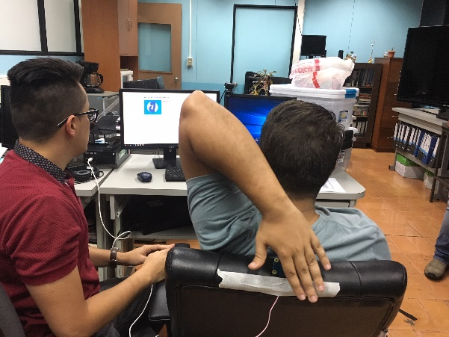

**Figure 10.** Shoulder stretch exercise

The second exercise chosen was the Leg extension. We placed the sensors below the office desk where the user was able to reach them when the leg was in a horizontal position. For this exercise, moving the chair a bit back was needed to reach the sensors adequately. We faced here the first problem with the sensors. The input was not recognized using shoes. The sensors recognizes changes in the voltage when a touch is received. Shoes did not provide the necessary input to be readable by the application. Fortunately, socks worked fine with the sensors. Apart from that, the exercise was performed with no issues and the user was able to complete it. In the following image we can see the exercise being performed.

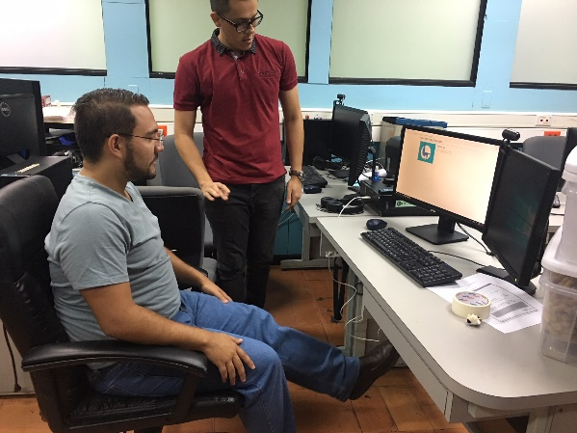 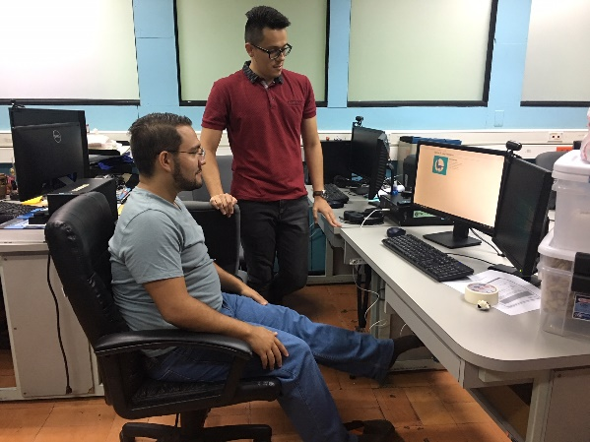

(a) (b)

**Figure 11.** Leg Extension Exercise. (a) shows the user with shoes. (b) shows the user after taking off the shoes to make the sensors identify touches.

The third exercise was the Spinal Stretch. We found that the position for the sensors can be an issue as not all the desks have the necessary form to place them correctly. The sensors have to be placed at each side of the user that is sitting on the chair. For this paper purpose, we placed one sensor in a chair and the second was placed in the desk. In the following images we can see how the user has to move in order to perform the exercise.

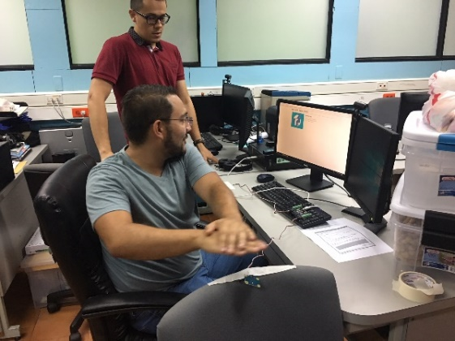 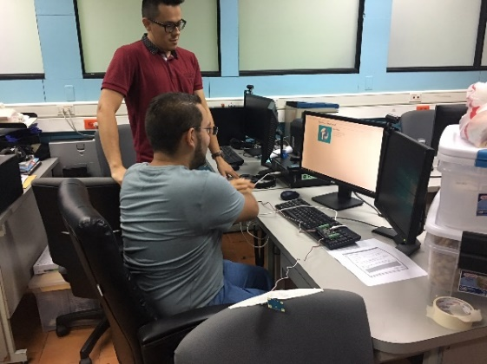

(a) (b)

**Figure 12.** Leg Extension Exercise. (a) shows the user touching the left sensor. (b) shows the user touching the right sensor located in a chair.

At this point the user indicated his body was already warm but without any sweat. The fourth and last exercise was the Knee Flex Push Ups. After indicating the position that needed to be adopted, the movement was pretty straight forward. At the beginning of this exercise, we thought sensors would not be recognized since the user has wearing pants, but the sensors were able to detect the inputs. In the next image, Fig. 13, we can see the user performing this last exercise.

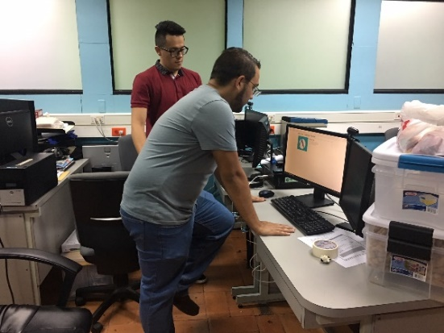

**Figure 13.** Knee Flex Push Up Exercise

From all of the exercises, we noticed that depending of the users speed, the sensors might not be able to recognize the input. In some scenarios, the user touch was recognized by a sensor but when touching the next one; an error message appeared indicating the same sensor was touched twice in a row. This behavior was only present when the user performed the movements way too fast. For the purpose of the activity, the exercises need to be performed at a moderate speed in order to be well executed.

From the beginning, the users indicated the application needed to show a more detailed description of the exercise, which arm or leg to start with? How many repetitions are needed to complete the exercise? Those were the most asked questions regarding the interface. Furthermore, we noticed it is also necessary to have an application that indicates the user when it is time to perform the physical activity.

In conclusion, at the end of the exercises the users were asked their general comments, among which they highlighted that it is a good way to ensure that activity is done at work, but in the same way, many improvement options were indicated.

For the purpose of this paper, with each exercise the position of the sensors was changed and in this way we only use at most two sensors at the same time. In order to integrate all the exercises without the need to move the sensors, seven sensors would be needed and an interface kit to connect them. Fortunately, this is perfectly possible since the kit interface allows connecting 8 sensors at the same time.

7. Conclusion

In this paper, we presented an exercise circuit to reduce a sedentary lifestyle in a workplace environment to improve the quality of life of people that spend most of their day in the office. Performing even a small amount of exercise on a daily basis is important and necessary to reduce the possibility of suffering deceases related to a sedentary lifestyle. Incorporating exercises in the workplace without interfering with the normal activities is very desirable. Having the possibility of tracking the exercises is even more important. It provides guidance, and above all, a method to be followed in order to perform the exercises correctly. Finally integrating the sensors in the chair and desk provide a way of implementing the exercise using the available items in the workplace.

We implemented an exercise circuit platform that consists of four exercises that blend into the workplace environment. By integrating touch sensors, we are able to detect the user inputs while performing the exercise, and thus, we can determine if the exercise movements are correct. An exercise interface was implemented to guide the user through the exercise, providing messages of the movements that are being detected and, if needed, showing messages indicating errors. The interface was very helpful showing the inputs detected by the sensors, but was missing more information about the current exercise.

During the evaluation the users were very pleased of the exercises chosen, as they cover the main parts of the body. Even more importantly, users were very pleased that the sensors could detect the movements, and appreciated that they were integrated with the workplace environment. However, in some cases we discovered that it can be challenging to position the sensors if the desk or chair does not have the required form. Several recommendations were made while using the sensors. The main one was how can we measure when is the time for the user to perform the exercises. Adding more sensors was one of the main comments during the evaluation, sensors to detect if the user is really sitting in the chair while performing the movements, or even another time of sensors, for example not only using touch sensors, but force sensors so the user needs to push with certain strength in order to complete the input. Adjusting the space was necessary for the users as the reach is not same for all of them. The acceptance of the exercise circuit platform was very satisfying, especially in an environment where most of the people spend hours every day.

References

1. Sedentary Behaviour Research Network. Standardized use of the terms “sedentary” and “sedentary behaviours”. Appl Physiol Nutr Metab. 2012. doi: 10.1139/h2012-024..
2. Biswas A, Oh P, Faulkner GE, Bajaj RR, Silver MA, Mitchell MS, et al. Sedentary time and its association with risk for disease incidence, mortality, and hospitalization in adults: a systematic review and meta-analysis. Ann Intern Med. 2015. doi:10.7326/M14-1651.
3. van der Ploeg HP, Chey T, Korda RJ, Banks E, Bauman A. Sitting time and all-cause mortality risk in 222497 Australian adults. Arch Intern Med. 2012. doi:10.1001/archinternmed.2011.2174.
4. Gardner, B., Smith, L. & Mansfield, L. BMC Public Health (2017) 17: 47. <https://doi-org.ezproxy.sibdi.ucr.ac.cr/10.1186/s12889-016-3974-0>
5. Thor, A.A., Healy, G.N., Winkler, E. et al. Int J Behav Nutr Phys Act (2012) 9: 128. <https://doi-org.ezproxy.sibdi.ucr.ac.cr/10.1186/1479-5868-9-128>
6. Buckley JP, Hedge A, Yates T, Copeland RJ, Loosemore M, Hamer M, et al. The sedentary office: a growing case for change towards better health and productivity. Expert statement commissioned by Public Health England and the Active Working Community Interest Company. Br J Sports Med. 2015. doi:10.1136/bjsports-2015-094618
7. Matthews CE, Chen KY, Freedson PS, Buchowski MS, Beech BM, Pate RR, et al. Amount of time spent in sedentary behaviors in the United States, 2003–2004. Am J Epidemiol. 2008;167:875–81.
8. Buckley JP, Mellor DD, Morris M, Joseph F. Standing-based office work shows encouraging signs of attenuating post-prandial glycaemic excursion. Occup Environ Med. 2014 Feb;71(2):109–11.
9. Thorp AA, Healy GN, Owen N, Salmon J, Ball K, Shaw JE, et al. Deleterious associations of sitting time and television viewing time with cardiometabolic risk biomarkers: Australian diabetes, obesity and lifestyle (AusDiab) study 2004-2005. Diabetes Care. 2010 Feb;33(2):327–34.

H:\documents\layout\new template June 2014\figures\CC-BY logo original v1.wmf© 2018 by the authors. Submitted for possible open access publication under the   
terms and conditions of the Creative Commons Attribution (CC BY) license (http://creativecommons.org/licenses/by/4.0/).